COMP – 371 Software Development And Construction
Lab Manual 08
Design Patterns
GithubLink: https://github.com/maliknabeel/designpatterns/tree/master/src/com/digicl/creationaldesignpatterns

Creational Design Patterns:
Creational design patterns focus on how objects are created and instantiated in an application. Instead of instantiating objects directly using new, these patterns provide better object creation mechanisms that are flexible, reusable, and scalable.
Singleton Design Pattern:
Singleton is a creational design pattern that lets you ensure that a class has only one instance, while providing a global access point to this instance.

- Ensure that a class has just a single instance.
Why would anyone want to control how many instances a class has? The most common reason for this is to control access to some shared resource—for example, a database or a file.
Here’s how it works: imagine that you created an object, but after a while decided to create a new one. Instead of receiving a fresh object, you’ll get the one you already created.
Note that this behavior is impossible to implement with a regular constructor since a constructor call must always return a new object by design
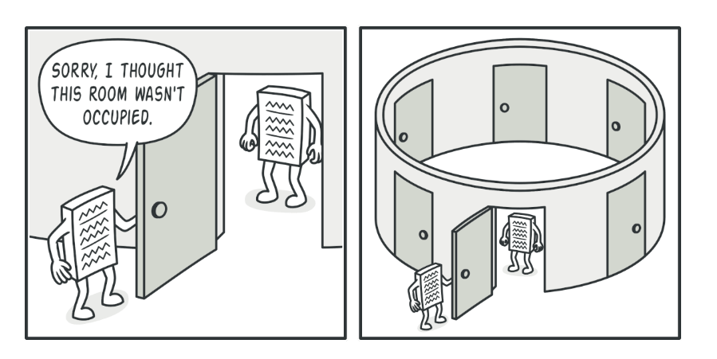
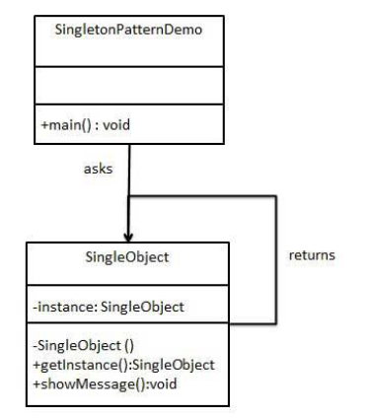

Provide a global access point to that instance. Remember those global variables
- handy, they’re also very unsafe since any code can potentially overwrite the contents of those variables and crash the app.
Just like a global variable, the Singleton pattern lets you access some object from anywhere in the program. However, it also protects that instance from being overwritten by other code.
There’s another side to this problem: you don’t want the code that solves problem #1 to be scattered all over your program. It’s much better to have it within one class, especially if the rest of your code already depends on it.
Nowadays, the Singleton pattern has become so popular that people may call something a singleton even if it solves just one of the listed problems.

Solution
All implementations of the Singleton have these two steps in common:
- Make the default constructor private, to prevent other objects from using the new operator with the Singleton class.
- Create a static creation method that acts as a constructor. Under the hood, this method calls the private constructor to create an object and saves it in a static field. All following calls to this method return the cached object.
If your code has access to the Singleton class, then it’s able to call the Singleton’s static method. So whenever that method is called, the same object is always returned.

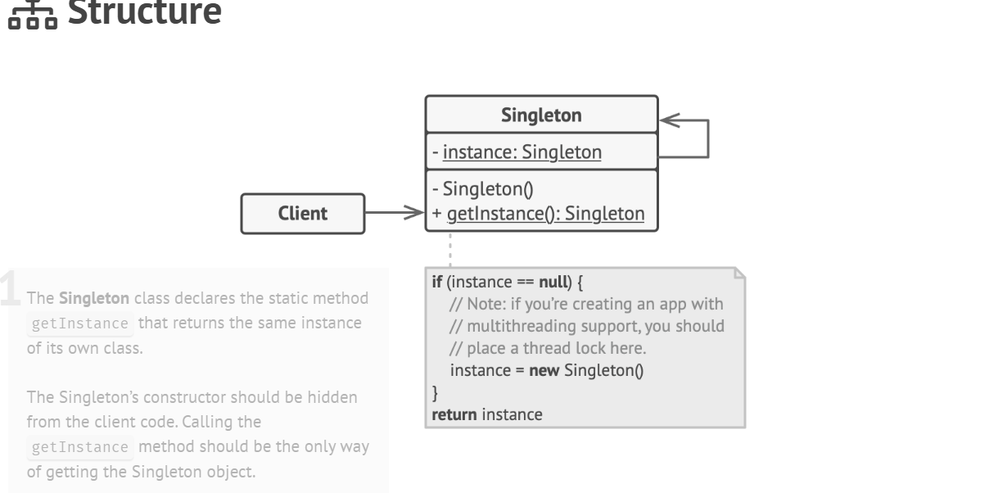

Applicability
Use the Singleton pattern when a class in your program should have just a single instance available to all clients; for example, a single database object shared by different parts of the program.

How to Implement
- Add a private static field to the class for storing the singleton instance.
- Declare a public static creation method for getting the singleton instance.
- Implement “lazy initialization” inside the static method. It should create a new object on its first call and put it into the static field. The method should always return that instance on all subsequent calls.
- Make the constructor of the class private. The static method of the class will still be able to call the constructor, but not the other objects.
- Go over the client code and replace all direct calls to the singleton’s constructor with calls to its static creation method.

Example :

class Singleton {
private static Singleton instance;
private Singleton() {}

public static Singleton getInstance() {
if (instance == null) {
instance = new Singleton();
}
return instance;
}

// Example method
public void showMessage() {
System.out.println("Hello, Singleton is working!");
}
}
public class Main {
public static void main(String[] args) {
Singleton obj1 = Singleton.getInstance(); obj1.showMessage();

Singleton obj2 = Singleton.getInstance();
System.out.println(obj1 == obj2); // Output: true
}
}

Prototype Pattern:
Prototype is a creational design pattern that lets you copy existing objects without making your code dependent on their classes

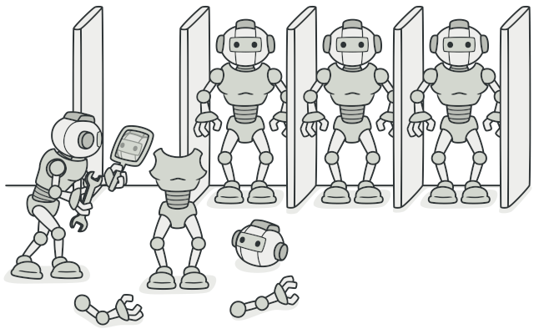
How To Implement Prototype:
- Step 1: Prototype interface – clone method
- Step 2: Concrete prototype class – alternative constructor (accepts the class object)
this constructor copies field from the passed object to the cloned copy
- If cloning a subclass – call the parent’s constructor (handle the cloning)
- Step 3: implementation of the clone method – just one line – call the constructor with the new operator
- Subclass – own implementation of the clone method
- Step 4 (optional): create a centralized prototype registry to store a catalog of frequently used prototypes.
// Step 1: Prototype Interface
interface Prototype {
Prototype clone();
}

// Step 2: Concrete Class
class Book implements Prototype {
String title;
String author;

// Constructor
public Book(String title, String author) {
this.title = title;
this.author = author;
}

// Clone method (Copy Constructor)
public Book(Book book) {
this.title = book.title;
this.author = book.author;
}

// Implement clone method
@Override
public Book clone() {
return new Book(this);
}

public void showBook() {
System.out.println("Book: " + title + " by " + author);
}
}

// Step 3: Main Class
public class Main {
public static void main(String[] args) {
// Original Book
Book book1 = new Book("Harry Potter", "J.K. Rowling");
book1.showBook();

// Cloning the book
Book book2 = book1.clone();
book2.showBook();

// Checking if they are different objects
System.out.println(book1 == book2); }
}
Factory Method:
Factory Method is a creational design pattern that provides an interface for creating objects in a superclass, but allows subclasses to alter the type of objects that will be created.
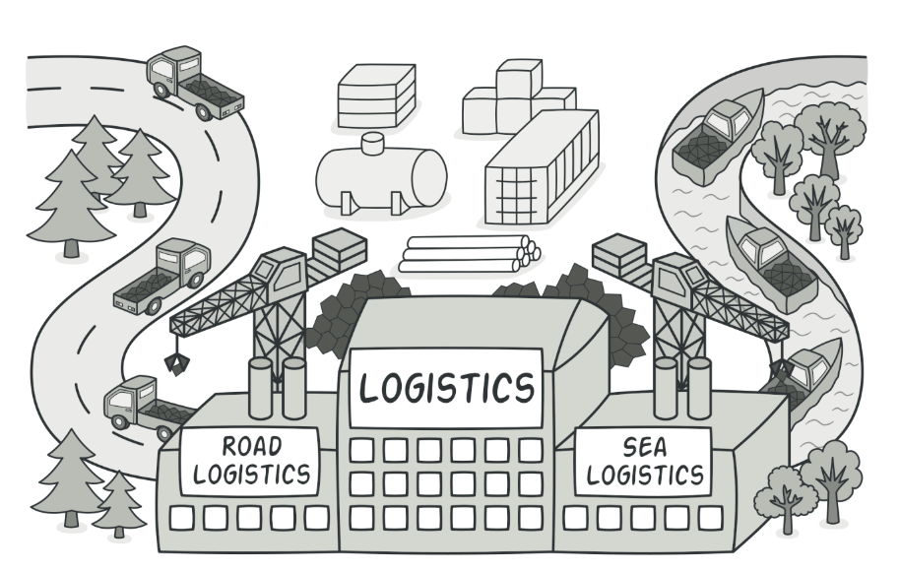

Problem
Imagine that you’re creating a logistics management application. The first version of your app can only handle transportation by trucks, so the bulk of your code lives inside the Truck class.
After a while, your app becomes pretty popular. Each day you receive dozens of requests from sea transportation companies to incorporate sea logistics into the app.

Adding a new class to the program isn’t that simple if the rest of the code is already coupled to existing classes.

Great news, right? But how about the code? At present, most of your code is coupled to the Truck class. Adding Ships into the app would require making changes to the entire codebase. Moreover, if later you decide to add another type of transportation to the app, you will probably need to make all of these changes again.
As a result, you will end up with pretty nasty code, riddled with conditionals that switch the app’s behavior depending on the class of transportation objects.

Solution
The Factory Method pattern suggests that you replace direct object construction calls (using the new operator) with calls to a special factory method. Don’t worry: the objects are still created via the new operator, but it’s being called from within the factory method. Objects returned by a factory method are often referred to as products.
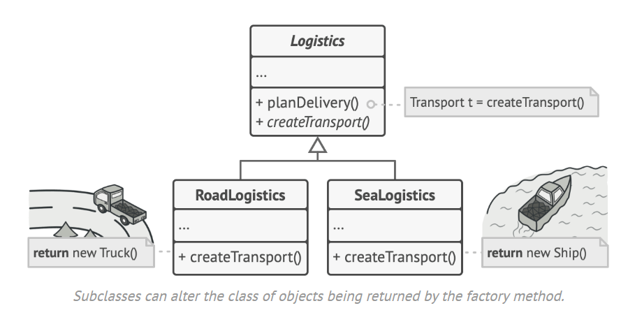

At first glance, this change may look pointless: we just moved the constructor call from one part of the program to another. However, consider this: now you can override the factory method in a subclass and change the class of products being created by the method.
There’s a slight limitation though: subclasses may return different types of products only if these products have a common base class or interface. Also, the factory method in the base class should have its return type declared as this interface.
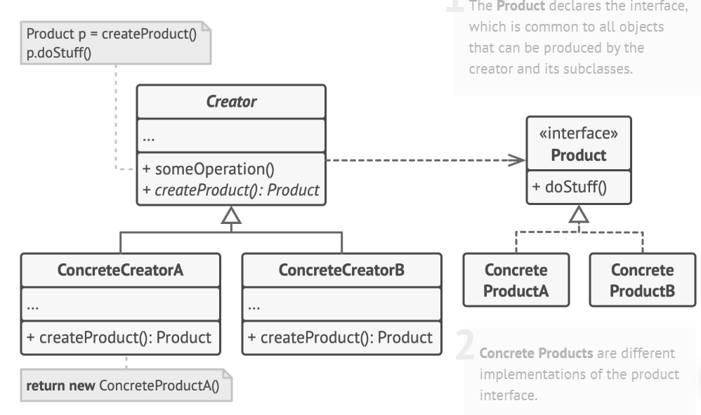

Pros
- You avoid tight coupling between the creator and the concrete products.
- Single Responsibility Principle. You can move the product creation code into one place in the program, making the code easier to support.
- Open/Closed Principle. You can introduce new types of products into the program without breaking existing client code.
Cons
- The code may become more complicated since you need to introduce a lot of new subclasses to implement the pattern. The best case scenario is when you’re introducing the pattern into an existing hierarchy of creator classes.

The Factory Pattern is used when you need to create objects in a way that:
- Hides Complexity: When the instantiation process is complex or involves many steps, a factory simplifies the creation of objects by encapsulating this complexity in a single location.
- Promotes Loose Coupling: When your code should depend on abstractions (interfaces or abstract classes) rather than concrete implementations. This makes your code more flexible and easier to maintain.
- Provides Flexibility in Object Creation:
  - If the exact class of the object to be created cannot be determined at compile time.
  - If the type of the object to be created is determined at runtime.
- Encapsulates Object Creation Logic: When you want to centralize the logic for creating objects to make it easier to update, maintain, and extend.
- Supports Polymorphism: When you want to create a family of related objects that share a common base class or interface but have different behaviors.
- Simplifies Code Changes:If the object creation process changes frequently, using a factory pattern isolates this change in the factory, avoiding the need to update it everywhere in your codebase.

Code Example:
// Step 1: Define an Interface for Ice Cream
interface IceCream {
void serve();
}

// Step 2: Implement Concrete Ice Cream Classes
class VanillaIceCream implements IceCream {
public void serve() {
System.out.println("Serving Vanilla Ice Cream!");
}
}

class ChocolateIceCream implements IceCream {
public void serve() {
System.out.println("Serving Chocolate Ice Cream!");
}
}

class StrawberryIceCream implements IceCream {
public void serve() {
System.out.println("Serving Strawberry Ice Cream!");
}
}

// Step 3: Create a Factory Class
class IceCreamFactory {
public static IceCream createIceCream(String type) {
switch (type.toLowerCase()) {
case "vanilla":
return new VanillaIceCream();
case "chocolate":
return new ChocolateIceCream();
case "strawberry":
return new StrawberryIceCream();
default:
throw new IllegalArgumentException("Unknown ice cream type: " + type);
}
}
}

// Step 4: Client Code
public class IceCreamShop {
public static void main(String[] args) {
// Get an ice cream of your choice
IceCream myIceCream = IceCreamFactory.createIceCream("vanilla");
myIceCream.serve();

IceCream anotherIceCream = IceCreamFactory.createIceCream("chocolate");
anotherIceCream.serve();
}
}

